Experiment 10 M. Devarajulu
Aim 192212058
To implement the A* (A-Star) Search Algorithm using Python

Algorithm
- Initialize the OPEN list with the start node and the CLOSED list as empty.
- Assign the heuristic value h(n) to each node.
- Calculate the evaluation function:
  - f(n) = g(n) + h(n)
  - where:
    - g(n) = Cost from the start node to node n.
    - h(n) = Estimated cost from node n to the goal node.
- Select the node with the lowest f(n) from the OPEN list.
- If the selected node is the goal node, stop and display the path.
- Otherwise, expand the node, update the costs of its neighbors, and repeat until the goal is reached.
Program
# A* Search Algorithm
graph = {
'A': [('B', 1), ('C', 3)],
'B': [('D', 3), ('E', 1)],
'C': [('F', 5)],
'D': [('G', 2)],
'E': [('G', 4)],
'F': [('G', 2)],
'G': []
}

# Heuristic values
heuristic = {
'A': 6,
'B': 4,
'C': 4,
'D': 2,
'E': 2,
'F': 1,
'G': 0
}

def astar(start, goal):
open_list = set([start])
closed_list = set()

g = {}
g[start] = 0

parents = {}
parents[start] = start

while len(open_list) > 0:

n = None

# Find node with lowest f(n) = g(n) + h(n)
for v in open_list:
if n is None or g[v] + heuristic[v] < g[n] + heuristic[n]:
n = v

# Goal reached
if n == goal:
path = []

while parents[n] != n:
path.append(n)
n = parents[n]

path.append(start)
path.reverse()

print("Shortest Path:", path)
print("Total Cost:", g[goal])
return

# Explore neighbors
for (m, weight) in graph[n]:

new_cost = g[n] + weight

if m not in open_list and m not in closed_list:
open_list.add(m)
parents[m] = n
g[m] = new_cost

elif new_cost < g.get(m, float('inf')):
g[m] = new_cost
parents[m] = n

if m in closed_list:
closed_list.remove(m)
open_list.add(m)

open_list.remove(n)
closed_list.add(n)

print("Path does not exist.")

# Driver Code
astar('A', 'G')

Output:

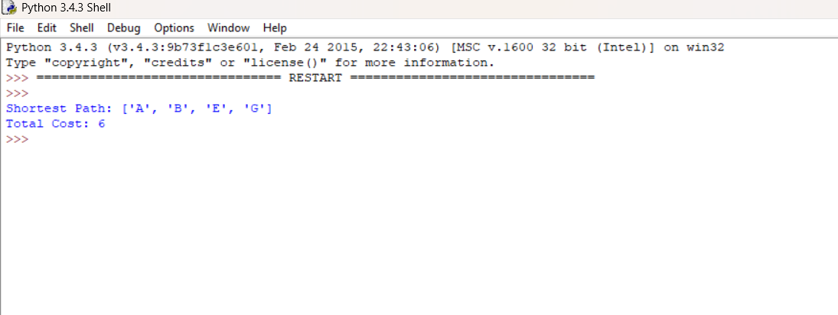

Result
The program successfully implements the A* Search Algorithm. It finds the shortest path from the start node A to the goal node G using both the actual path cost (g) and heuristic estimate (h).

